What is IO-Link?
IO-Link is a bi-directional point-to-point serial communications protocol; most commonly used to communicate with sensors and/or actuators. It allows three types of data to be exchanged: Process, service, and events data.
What is an IO-Link master?
In the simplest form: a standard digital I/O device that is able to interpret automation languages (EtherNet/IP, ModBus, etc) and translate to a host of other IO-Link devices (ex: sensors, actuators). The IO-Link Master can provide diagnostics, monitor usage, and allow remote management of sensors.
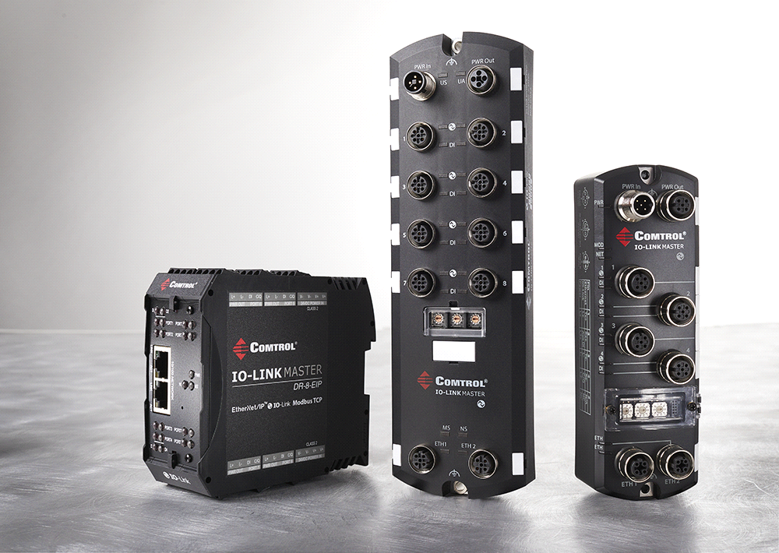
IO-Link uses the global standard IEC 61131-9.
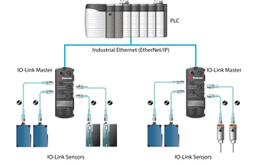
Figure 1: IO-Link connectivity from the PLC. Figure 2: Comtrol’s IO-Link products.

Quick Overview of Benefits:
IO-Link has...
1. Higher Level of Flexibility:
Easy to read, parameterize or configure smart devices without touching them.
2. Simple Device Replacement:
Simple replacement of devices by being able to download parameters into the replacement right from the controller automatically. This allows the user to never redo work that has already been done.
3. IO-Link is an Open Consortium of Manufacturers:
New products are released on a regular basis and IO-Link is gaining ground in North America. It's already widespread in Europe.
4. Simple Serial Point to Point Communication:
Uses a simple standardized cabling architecture.
5. Multiple Smart Devices per Address:
A basic benefit of IO-Link is to allow for multiple smart network type devices to be connected to one address and thus allowing for more devices to be connected in one network.

Primary User Benefits...
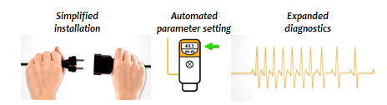
- Long-term cost reductions at all levels.
- Minimized downtimes through intelligent remote management.
- Standardized for easy operation.
- Comprehensive device diagnosis down to field level.
- Enhanced flexibility in application.
- Long-term investment security due to international standardization.

What's the Point? Why IO-Link?
IO-Link is a powerful, yet simple protocol with wide support in the industry. IO-Link has the potential to replace almost any place that a digital or analog sensor is used. This allows for much more significant information, configurability, and control.
IO-Link allows the user to choose from a variety of sensors and/or actuators without investing everything in one company.
IO-Link can be used on new projects or be integrated into any existing fieldbus system (ex: Ethernet/IP ProfiNet, modbus).
IO-Link allows the user to place an IO-Link device in an area that is dangerous or difficult to access without worry. The operator can configure their smart devices without physically going to its location.

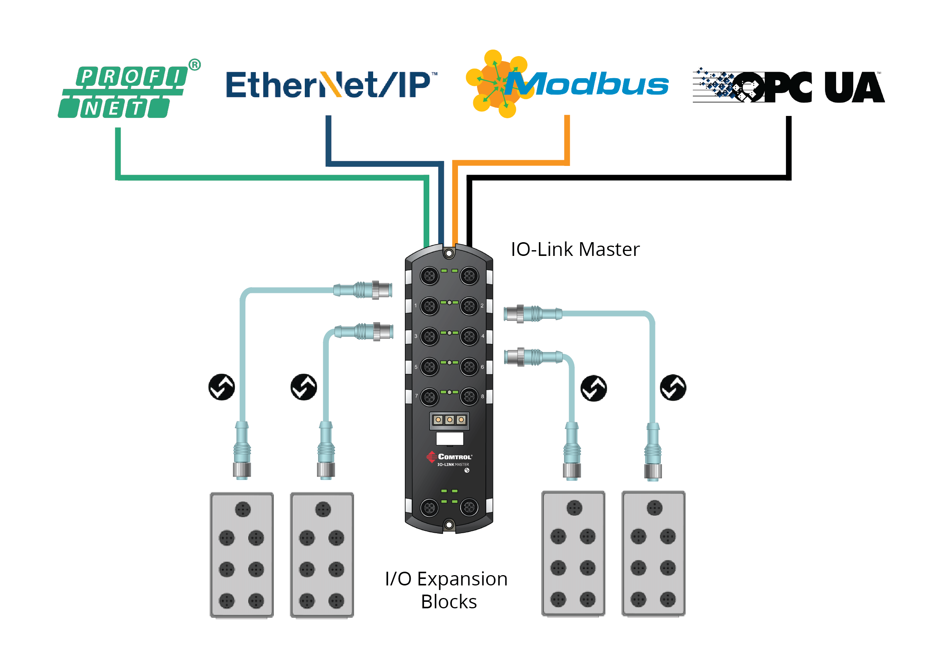
IO-Link users can fully benefit from multiplexing.
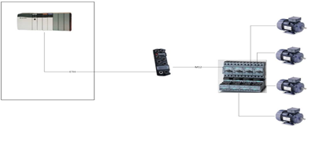
Figure 3: Multiplexing via IO-Link motor starters. One cable from the PLC to IO-Link Master is all the user needs.

Comtrol Specific Features?
Diagnostic Capabilities
- View real-time diagnostics through the embedded webpage.
Remote Parameterization
- Comtrol's IO-Link enables remote communication from a PLC or HMI to a sensor in order to change a sensor's configuration or operational behavior. Can be used simply by accessing the IO-Link master web interface (NO PLC/HMI needed).
Multi-Link
Allows for communication with Ethernet/IP or Profinet/IO AND Modbus TCP devices simultaneously. Additionally, no PLC needed to run and operate the master.

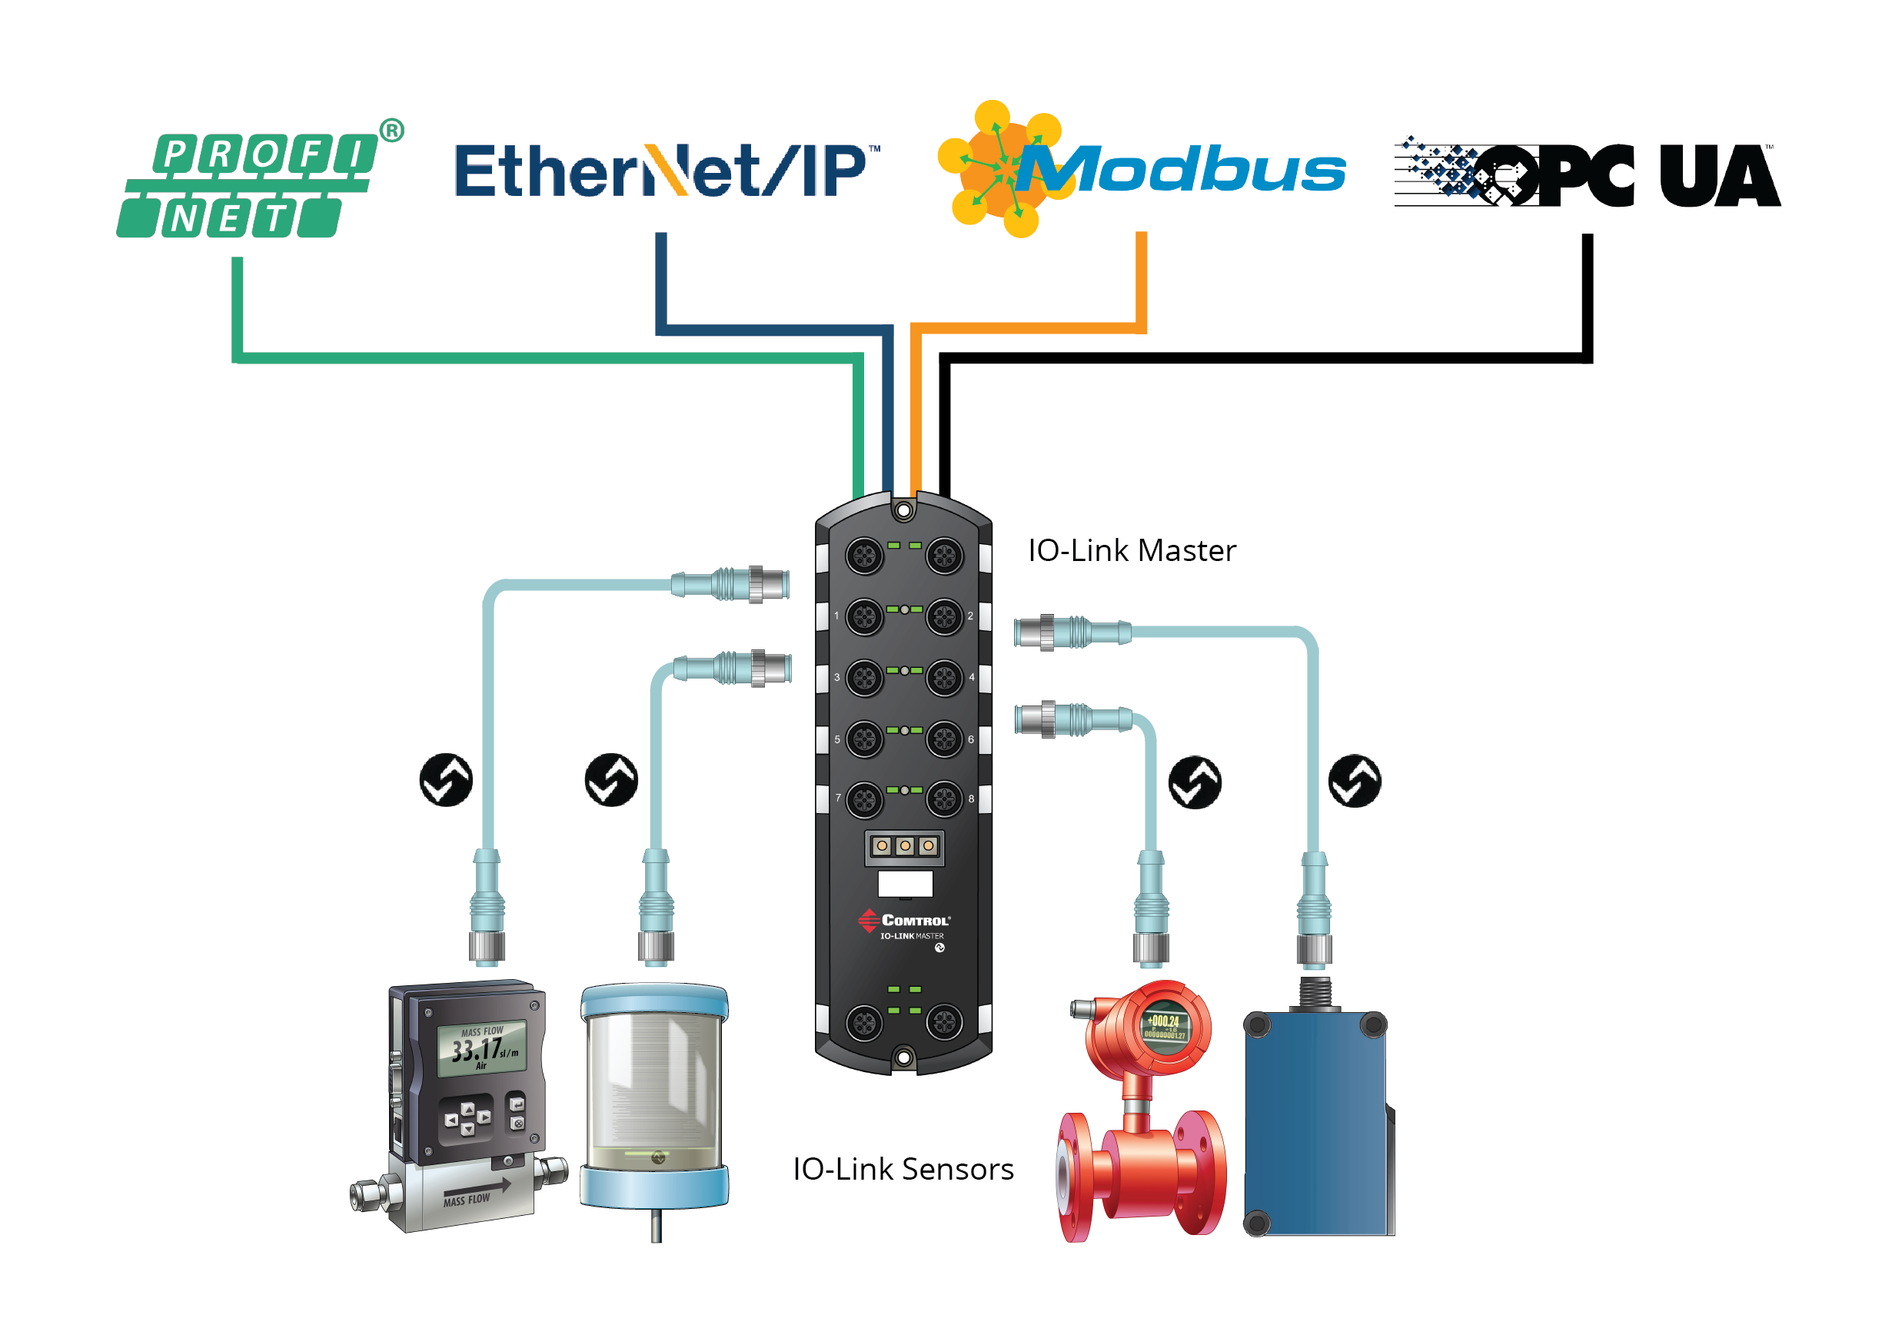
Mobile Access
- Access IO-Link data through a phone via any Modbus Client.
Web Interface (Embedded Webpage)
- Configure IO-Link, Modbus, etc.
Network Management Tools
- Comtrol's PortVision DX management application allows you to configure network settings, upload firmware, manage and monitor IO-Link attached devices.
DIN-Rail Option
- Comtrol is the ONLY North American IO-Link gateway provider to have a DIN-Rail option.
- Multi form-factor options: IP67 M12 for on machine, and IP20 in cabinet.
Auto-Device Configuration (and how it works)
- Allows the user to replace a sensor with another very easily. The IO-Link device will recognize a factory default new device and implement all the same settings as the previous, replaced device. This will minimizes downtime by eliminating the need to set the parameters of the newly connected sensor.
ISDU Handling
- Eliminates lengthy and complex PLC programming to provide access to ISDU and process data.

Summary

As IO-Link becomes more widely used, it’s important to note that the IO-Link Master is here to make the operator’s job easier. Compared to traditional configuration methods of sensors, IO-Link implements features such as embedded web pages and simple device replacement – these minimizes downtime and provide extended diagnostics.

For more information, visit www.Comtrol.com
(763) 957-6000

