How do I set my IO-Link Master up?
Purpose: This document will cover the set up for an IO-Link Master - from box to fully operational.
Steps involved: 1. Network
2. Power
3. Devices
4. IODD Files
5. Embedded Web Page and PortVision.

[Network]:
1a. If you’re setting up a network address and want to have a fixed network address, you’ll want to set up Rotary Switches located on the IOLM itself. The Rotary Switches override any network settings changed via web interface. To set-up, visit: http://downloads.comtrol.com/html/IOLM_EIP4_install_RotarySwitch.htm
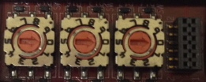

1b. However, for most customers the web interface or PortVision DX (*) will work to set the network address. The IOLM provides fast Ethernet (10/100BASE-TX) M12 connections (4-pin female / D-coded).

*PortVision DX is software made by Comtrol to help configure settings and view device status.
View [PortVision & Webpage] for more information.

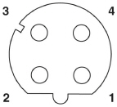  PIN | SIGNAL
1 | TX+
2 | RX+
3 | TX-
4 | RX-
*M12 connector with 4 pin outs *Each pin out with signal

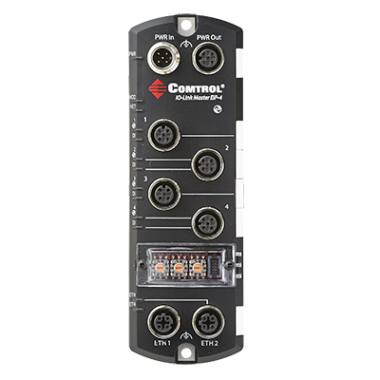
For IO-Link Master 4-EIP, plug M12 connections in either ETH1 or ETH2. Then plug Ethernet into designated site.
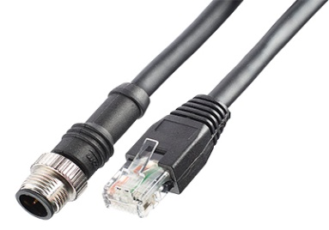
*Ethernet Cable (D-coded) M12 Male to RJ45

Note: You can daisy-chain to another Ethernet device by using ETH2.

[Power]:
2a. For the IOLM (for this example, 4port E/IP), the power ports will be located at the top. You’ll need M12 (A-coded) power connectors.
Strip wire to reveal bare copper, then connect to respective + and – grounds to power supply unit
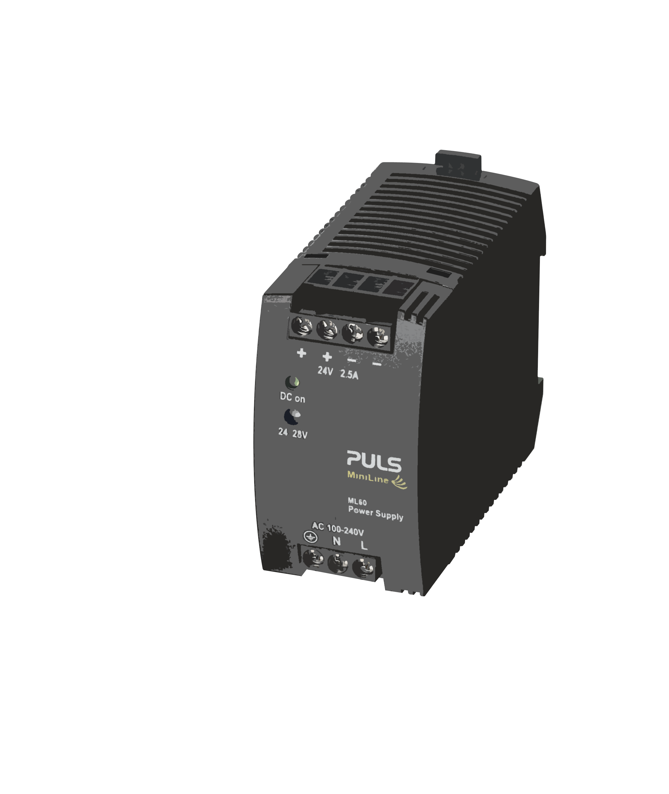
Connect A-Coded female
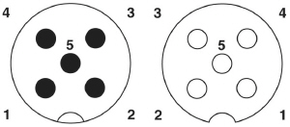
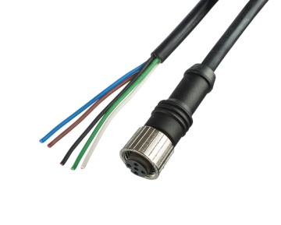
2b. Once you’ve successfully connected the power, apply the power and verify that PWR is a green lit LED.
DI should be off to indicate that there is no device attached to the port.

For specific pin outs and power supply voltage, please visit (page 6): http://downloads.comtrol.com/IO_Link_Master/4_EIP/Docs/TechTips/Initial_IOLM_Setup.pdf

[Devices]:
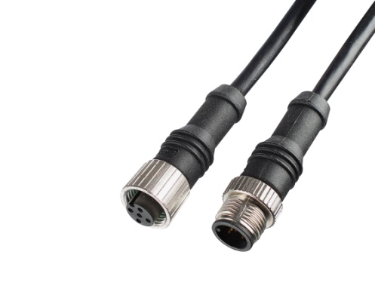
3a. You can now connect your IO-Link devices!
Any sensors and/or actuators will need to be connected via power cable A-Coded M12 (shown right).
Connect M12 connectors here. Once connected, the LED on the left-hand side will be solid green.

[IODD]:

4a. Now, each IO-Link device needs an IODD (IO Device Description) file.
The IODD is a set of files that formally describes a device. This allows for IO-Link to identify, communicate, parameterize and diagnose the device. The IODD file is mandatory for each IO-Link Device.
If you didn’t have an IODD file, you wouldn’t be able to do anything with your IO-Link device.

4b. For your specific IO-Link device, please visit the manufacturer’s website; navigate to their specific IODD files.
*Note: some companies have ALL their devices’ IODD files in one folder.

The IODD file consists of the main IODD file, and optional language and/or picture files.
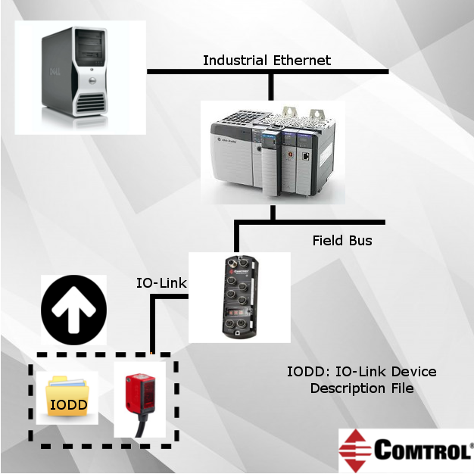

4c. To load IODD files, go to IP address of IOLM, ‘Attached Devices’ tab, and upload file.

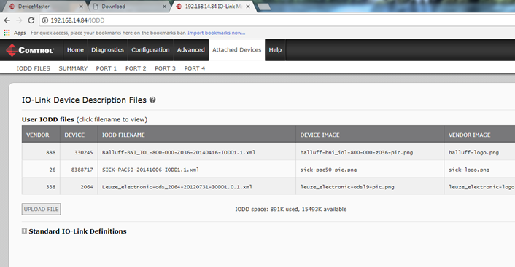

[PortVision & Webpage]:

5a. In order to start configuration and set certain parameters, you’ll need to download PortVision DX (Comtrol application). PortVision DX is a utility that discovers your device, facilitate installation, management, and monitor Comtrol products.

To download PortVision, visit: http://downloads.comtrol.com/html/IOLM_EIP_pvdx.htm

5b. Once PortVision is installed, scan for devices on the top left.
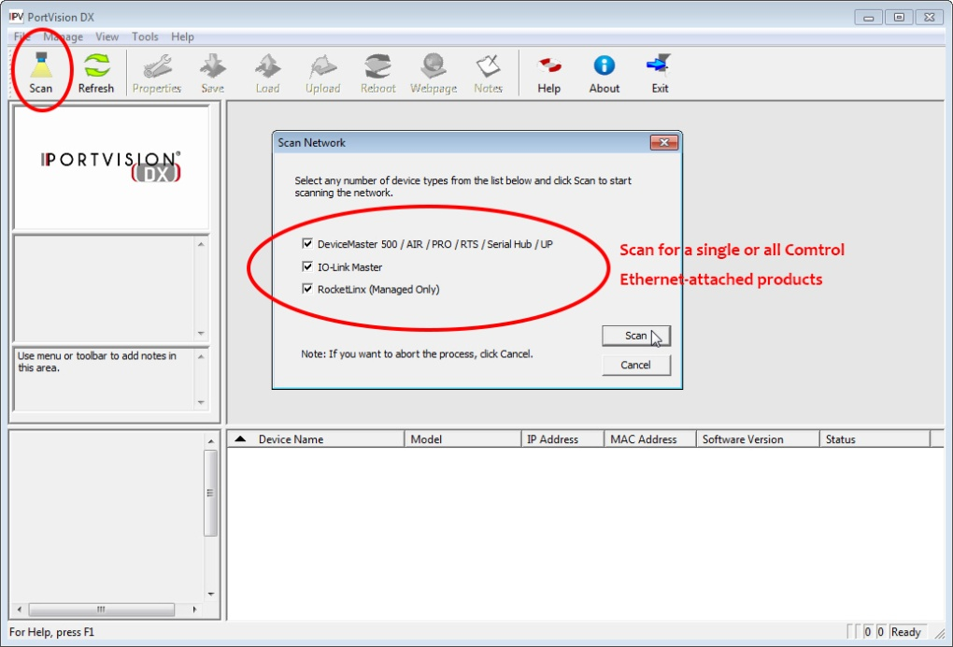

Once you’ve found your device, the device name, model, IP Address, etc will show up. At this point, if everything was installed correctly, the status will show ON-LINE.
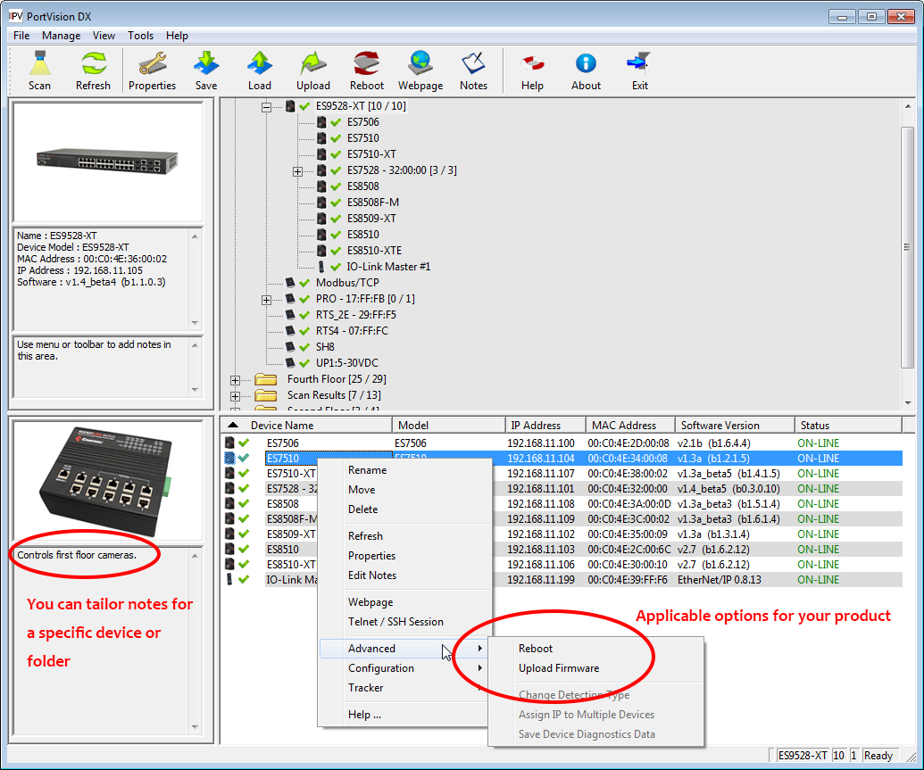
5c. As far as software version, the IOLM is loaded with the latest images at the factory, but you may need to update images or application subassemblies to have access to the latest features.
You can use either PortVision DX to load the software or the webpage.
For the webpage, type into a browser the IP address of your IOLM. Then, go to advanced tab, software page.

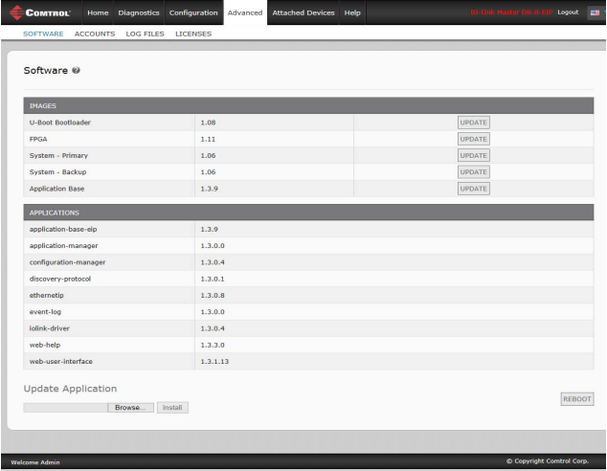
Visit: http://downloads.comtrol.com/html/IOLM_EIP_Software.htm for specific devices (4-EIP, 8-EIP, DR-EIP).
Summary:
Your IO-Link Master is now set-up and ready to be used. To change specific parameters, click on the configuration tab in the webpage. This guide only scratched the surface of IO-Link; however, please visit our other guides to more specific IO-Link parameters.

For additionally assistance, please visit: http://downloads.comtrol.com/IO_Link_Master/4_EIP/Docs/TechTips/Initial_IOLM_Setup.pdf

Comtrol Technical Support #: (763) 957-6000

