Purpose: Now that you’ve been introduced to IO-Link, this page will explain the logistical details.

Comtrol’s IO-Link Master
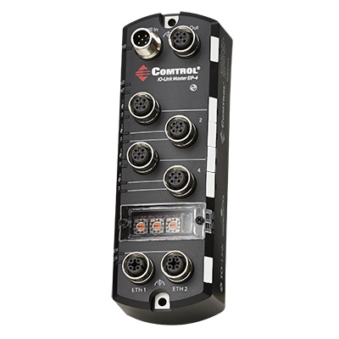
Power In / Power Out:
- The Power is 24 VDC and Signal (similar to three wire RS232) through one cable.
- To connect the power, the user will need a power supply. Connect the power supply cable to PWR IN. Then connect V+ and V- respectively. The IOLM (IO-Link Master) requires a UL listed LPS power supply with an output rating of 24 VDC. Power connectors must have an approved cable or protective cover attached to the connector to guarantee IP67 compliance.
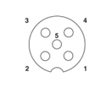
IO-Link (Ports):
- Female Connectors (M12), A-Coded
Pins: 1 = L+
2 = DI
3 = L-
4 = C/Q **
5 = Not Connected
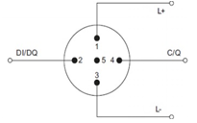
*Note: This is where the user will connect their devices (ex: sensors)
**Can be configured as IO-Link, digital input, digital output

Network Connections:
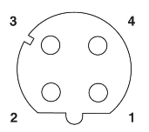
- Female Connectors (M12). ETH1 & ETH2 are 10/100BASE-TX, D-Coded
Pins: 1 = Tx+
2 = Rx+
3 = Tx-
4=Rx-

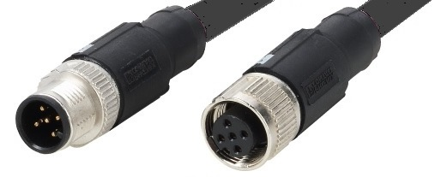
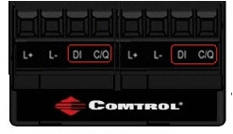

Power Specifications:
Power Supply Voltage/Current | Values
Voltage Input Range | 20 to 30 VDC
Current (for the IOLM 4-EIP) | 100mA
Maximum Output Current | 1.9A†
Note: The total supply of current for all connected IO-Link devices | The IOLM 4-EIP requires a UL listed power supply with an output rating of 24VDC

IO-Link (ports) Specifications:
Pin | Input – Male | Output - Female
1 | L+ | L+
2 | L2+ | L2+
3 | L- | L-
4 | L2- | L2-
5 | Not | Connected

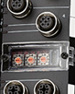
Rotary Switches:
You can use the rotary switches under the configuration window on the IOLM to set the network address in the field. Optionally, you can use the web interface to set network address to use PortVision DX. The switches will override the network settings in the web interface.

(Below are Rotary Switch settings for different network configurations)
Switch Setting | Node Address
000  (Default setting) | Use the network configuration stored in the flash.  The default network configuration values are:  - IP address = 192.168.1.250  - Subnet mask = 255.255.255.0  - IP gateway = 0.0.0.0
001-254 | This is the last three digits in the IP address. This uses the first three numbers from the configured static address, which defaults to 192.168.1.xxx.
255-887 | Reserved
888 | Reset to factory defaults.
889-997 | Use the network configuration values stored in the flash (reserved).
998 | Use DHCP addressing.
999 | Use the default IP address.

What are the Different Types of Data?
Previously mentioned, IO-Link uses three different types of data:
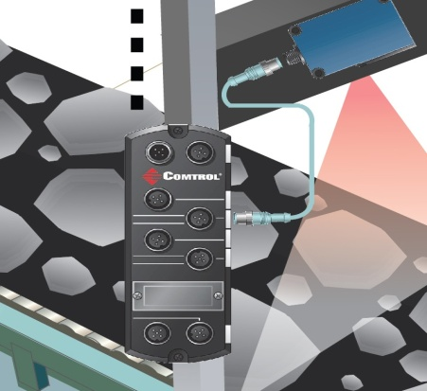

Process Data: Shows the latest state of the sensor, whether it's input or output data; communicates between 1 bit and 32 bytes of information every cycle (usually 2 ms).
- Cyclic Data: Information that the device is intended to deliver or measure (ex: temperature)
Service Data: Service Protocol Data Units (SPDUs) allow the user to retrieve detailed information about the device. This data allows up to sixteen thousand blocks to communicate; everything from basic device information (ex: versions, type, serial numbers, etc) to advanced information (ex: configuration, detailed diagnostics or status). This data is used to make parameter changes on an IO-Link Device.
-Acyclic Data: All data that is not relative to the process data the sensor outputs to the PLC / controllers (ex: manufacturer name, model number).

Events Data: This type of data rarely occurs, but should be reported without waiting for an SPDU to be queried. This allows standard or vendor specific information to be delivered as they are encountered (ex: alarms or informational messages).
- When specified critical events occur, "event flags" are transmitted to PLC or controllers for maintenance (ex: open circuits, communication aborts, overloads, etc).

Functionality?
Each IO-Link device needs an IODD (IO Device Description) file.
The IODD is a set of files that formally describes a device. This allows for IO-Link to identify, communicate, parameterize and diagnose the device. The IODD file is mandatory for each IO-Link Device.
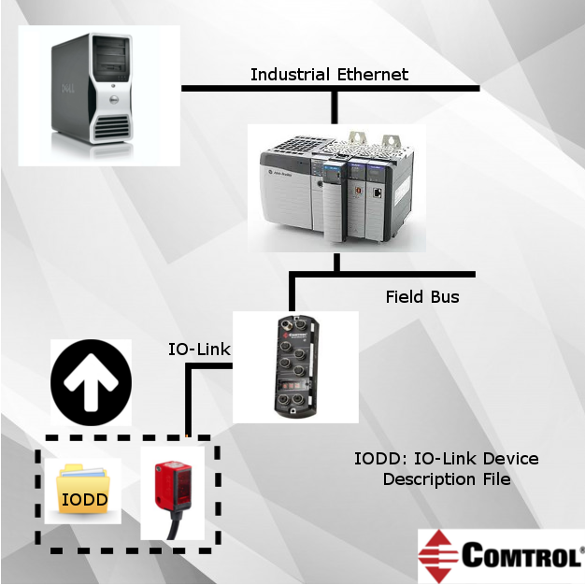
The IODD file consists of the main IODD file, and optional language and/or picture files. They’re able to be found on the vendor’s website for that particular sensor.

Architecture of IO-Link (Still Work-in-Progress)

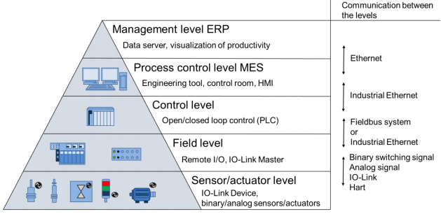

For additionally information, please visit: http://downloads.comtrol.com/IO_Link_Master/DR_EIP/Docs/IOLM_EIP_UserGuide.pdf

Comtrol Technical Support #: (763) 957-6000

