Configuring Comtrol Trace Control Utility
Select "Load Settings"

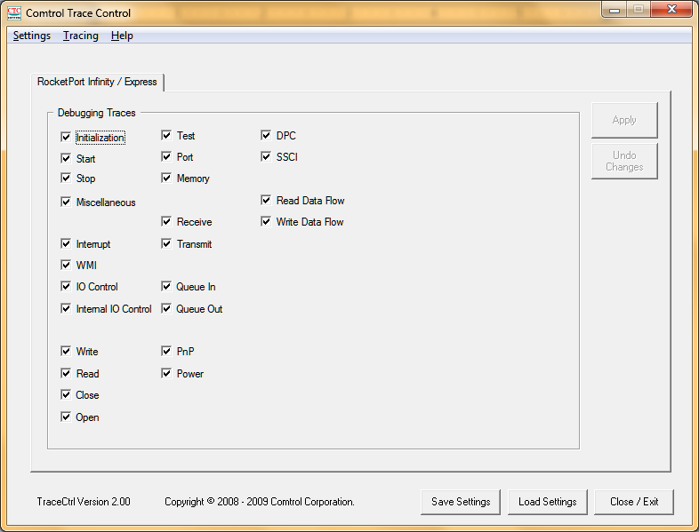

Choose the .tcc file you want to load.

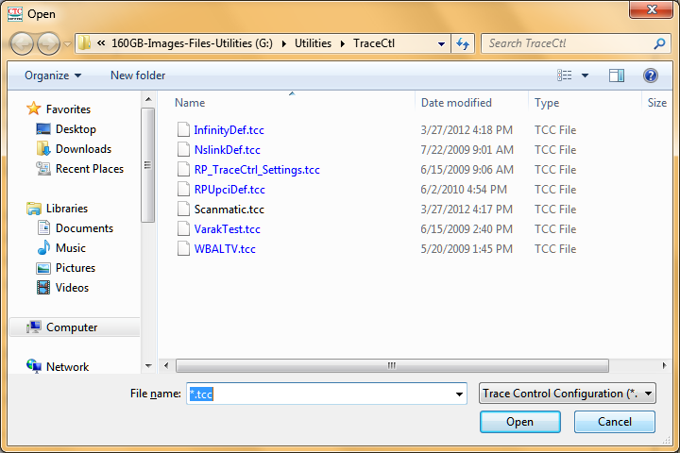
Select "Tracing at the top. Then Choose "Trace logging options"

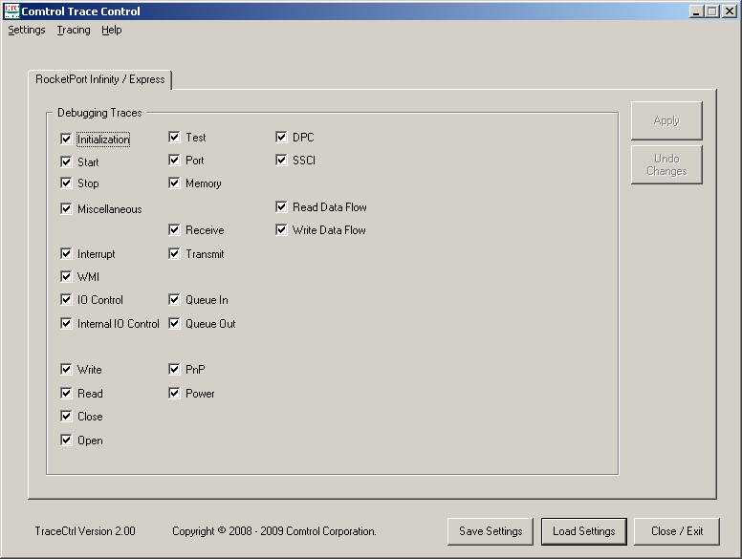

Check to see if settings are as below. If necessary make changes to ensure that "Create hew log" is selected and the file size is as shown.
Enter the path and filename for the trace file. Select "Save".

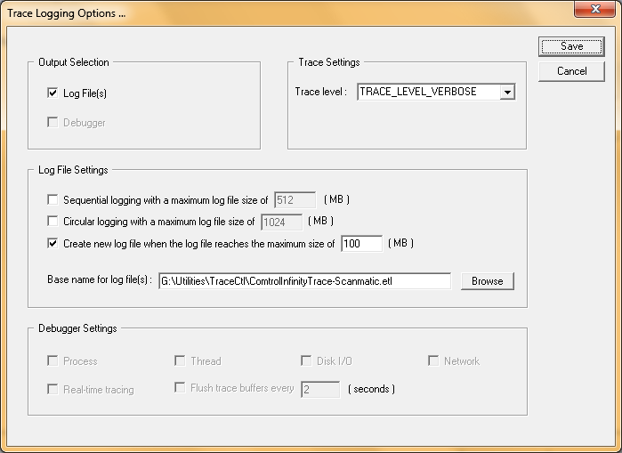

Select "Tracing" at the top. "Start Trace Logging".
Select "Apply" to apply trace settings.

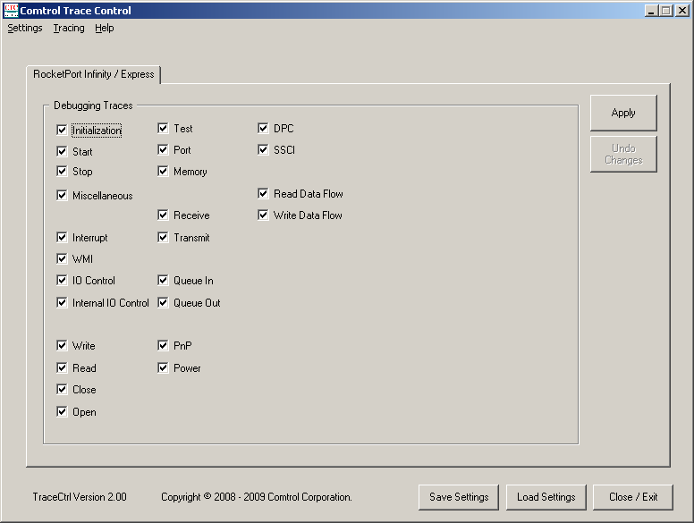

When you finish tracing, select "Tracing" at the top then "Stop tracing".

